DOCUMENTATIE

TEMA 2

NUME STUDENT: RUSU VLAD CRISTIAN
GRUPA: 30224

CUPRINS

1. Obiectivul temei 3
2. Analiza problemei, modelare, scenarii, cazuri de utilizare 3
3. Proiectare 4
4. Implementare 4
5. Rezultate 5
6. Concluzii 14
7. Bibliografie 14

Obiectivul temei
Obiectivul principal al temei a fost crearea unui sistem de eficientizare al cozilor care sa aiba ca efect un timp de asteptarea minim pentru client.

Obiectivele secundare care au aparut in vederea rezolvarii problemei principale au fost:
- Realziarea unor clase care sa reprezinte corect modelele de date necesare;
- Realizarea unei logici pentru eficientizare;
- Impartirea cozilor pe threaduri (o coada -> un nou thread);
- Interfata grafica care permite modificarea parametrilor introdusi;
- Generearea aleatoare de client pentru o testarea cat mai genereala;

Analiza problemei, modelare, scenarii, cazuri de utilizare
Cerintele functionale ale problemei sunt:
- Generarea unui numar specific de client impreuna cu toate atributele acestor;
- Impartirea clientilor la cozi in functie de cel mai mic timp de asteptare;
- Servirea clientilor in ordinea sosiri si pe durata timpului de servire al fiecaruia;
- Afisarea statusului cozilor la fiecare moment de timp;
- Oprirea simulari cand nu mai exista clienti sau cand s-a depasit timpul maxim de simulare;

Cerintele non-funtionale ale problemei sunt:
- Sistemul ar trebui sa suporte un numar mare de cozi si client;
- Sistemul ar trebui sa trateze toate erorile si exceptile intalnite;
- Sistemul ar trebui sa fie usor de folosit;
- Sistemul ar trebui sa fie usor de intretinut si modificat cu cod clar si bine documentat;

Use caseul problemei este urmatorul:
Se ruleaza programul iar o interfata grafica va aparea. Aici se pot seta numarul de client si de cozi precum si timpul maxim de simulare. Se apasa mai apoi butonul START SIMULATION iar simularea incepe. Pe text boxul din interfata vor aparea clientii generati aleator iar apoi in consola se va vedea starea cozilor o data cu timpul pana la finalul simularii. De asemenea, toate datele unei rulari vor fi salvate intr-un log;

Proiectare
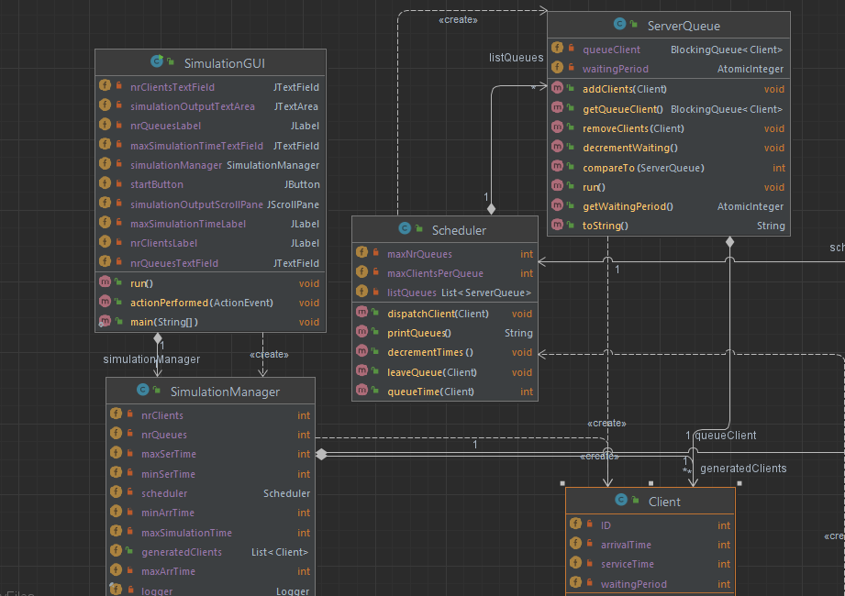

Proiectul contine 5 clase impartite in 3 pachete:
- Pachetul BussinesLogic cuprinde clasele:
- Scheduler;
- SimulationManager;
- Pachetul GUI este format din clasa SimulationGUI;
- Pachetul Models care contine
    - Client;
    - ServerQueue;

Implementare
Clasa Client contine 3 atribute: ID, arrivalTime , serviceTime. Aceasta este o clasa de model de date asa ca metodele acesteia consista in gettere si settere si metode suprascrise cum ar fi toString.

Clasa ServerQueue este tot o clasa model ce are ca attribute urmatoarele:queueClient care este un BlockingQueue un tip de variabila threadsafe,waiting period care reprezinta timpul de astepare al cozii. Aceasta clasa contine metode de adaugare a clientilor in coada si de eliminare a acestora din coada.
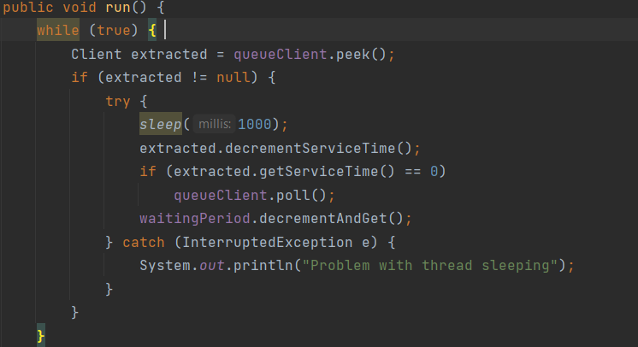

Clasa SimulationManager este clasa care realizeaza simularea cozilor. Metodele importante ale acesteia sunt metoda de generare aleatoare a clientilor:
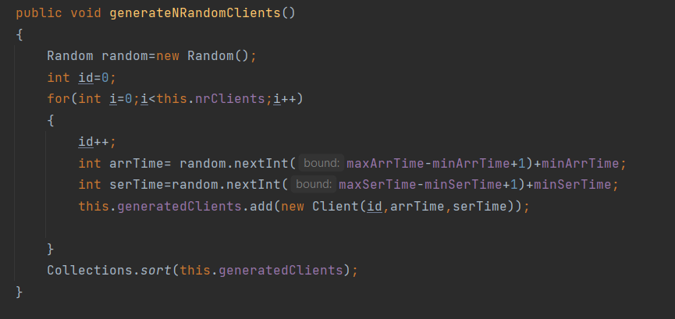

Metoda a doua este metoda suprascrisa run pentru thread-uri care aici realizeaza logica dupa care clienti sunt pusi in cozi si scosi din ele odata ce s-a terminat serviceTime-ul;

Clasa SimulationGUI realizeaza interfata in grafica din care poate fi pornita simularea si in care se pot introduce parametrii simularii, cum ar fi numarul de clienti si de cozi precum si timpul de simulare:
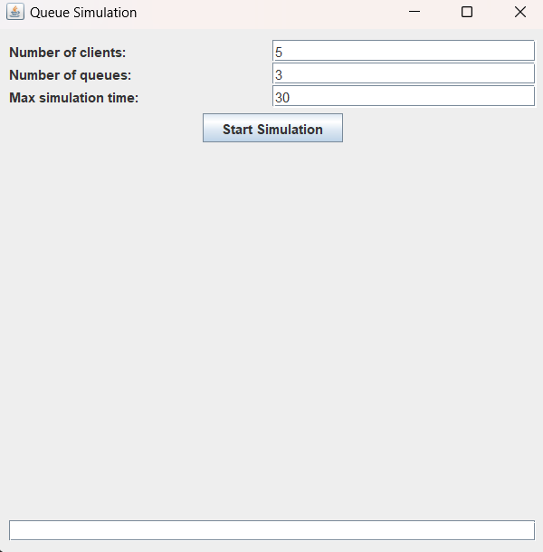

Clasa Scheduler realizeaza distribuirea clientilor dupa strategia “la coda cu timpul de asteotare cel mai mic”. De asemenea, aici se realizeaza si metoda care scoate clientii din coada. Atributele prezente in aceasta clasa sunt o lista de ServerQueues, numarul maxim de cozi si numarul maxim de clienti pe coada.

Rezultate
I.Primul scenariu de testare a fost urmatorul:
N=4;
Q=2;
TMax=60;
[Tmin arr,Tmax arr]=[2,30];
[Tmin ser,Tmax ser]=[2,4];

Iar lista de client generate aleator a fost:
ID=3 arrTime=5 serTime=3
ID=1 arrTime=6 serTime=3
ID=4 arrTime=6 serTime=3
ID=2 arrTime=20 serTime=3
Rezultatele:
Apr 24, 2023 9:57:02 AM BussinesLogic.SimulationManager run
INFO: current time:0
coada0[]
coada1[]

Apr 24, 2023 9:57:03 AM BussinesLogic.SimulationManager run
INFO: current time:1
coada0[]
coada1[]

Apr 24, 2023 9:57:04 AM BussinesLogic.SimulationManager run
INFO: current time:2
coada0[]
coada1[]

Apr 24, 2023 9:57:05 AM BussinesLogic.SimulationManager run
INFO: current time:3
coada0[]
coada1[]

Apr 24, 2023 9:57:06 AM BussinesLogic.SimulationManager run
INFO: current time:4
coada0[]
coada1[]

Apr 24, 2023 9:57:07 AM BussinesLogic.SimulationManager run
INFO: current time:5
coada0[]
coada1[]

Apr 24, 2023 9:57:08 AM BussinesLogic.SimulationManager run
INFO: current time:6
coada0[]
coada1[]

Apr 24, 2023 9:57:09 AM BussinesLogic.SimulationManager run
INFO: current time:7
coada0[]
coada1[]

Apr 24, 2023 9:57:10 AM BussinesLogic.SimulationManager run
INFO: current time:8
coada0[]
coada1[]

Apr 24, 2023 9:57:11 AM BussinesLogic.SimulationManager run
INFO: current time:9
coada0[]
coada1[]

Apr 24, 2023 9:57:12 AM BussinesLogic.SimulationManager run
INFO: current time:10
coada0[ID=2 arrTime=10 serTime=2]
coada1[]

Apr 24, 2023 9:57:13 AM BussinesLogic.SimulationManager run
INFO: current time:11
coada0[ID=2 arrTime=10 serTime=1]
coada1[ID=3 arrTime=11 serTime=3]

Apr 24, 2023 9:57:14 AM BussinesLogic.SimulationManager run
INFO: current time:12
coada0[]
coada1[ID=3 arrTime=11 serTime=2]

Apr 24, 2023 9:57:16 AM BussinesLogic.SimulationManager run
INFO: current time:13
coada0[]
coada1[ID=3 arrTime=11 serTime=1]

Apr 24, 2023 9:57:17 AM BussinesLogic.SimulationManager run
INFO: current time:14
coada0[]
coada1[]

Apr 24, 2023 9:57:18 AM BussinesLogic.SimulationManager run
INFO: current time:15
coada0[]
coada1[]

Apr 24, 2023 9:57:19 AM BussinesLogic.SimulationManager run
INFO: current time:16
coada0[]
coada1[]

Apr 24, 2023 9:57:20 AM BussinesLogic.SimulationManager run
INFO: current time:17
coada0[]
coada1[]

Apr 24, 2023 9:57:21 AM BussinesLogic.SimulationManager run
INFO: current time:18
coada0[]
coada1[]

Apr 24, 2023 9:57:22 AM BussinesLogic.SimulationManager run
INFO: current time:19
coada0[ID=4 arrTime=19 serTime=3]
coada1[]

Apr 24, 2023 9:57:23 AM BussinesLogic.SimulationManager run
INFO: current time:20
coada0[ID=4 arrTime=19 serTime=2]
coada1[]

Apr 24, 2023 9:57:24 AM BussinesLogic.SimulationManager run
INFO: current time:21
coada0[ID=4 arrTime=19 serTime=1]
coada1[ID=1 arrTime=21 serTime=3]

Apr 24, 2023 9:57:25 AM BussinesLogic.SimulationManager run
INFO: current time:22
coada0[]
coada1[ID=1 arrTime=21 serTime=2]

Apr 24, 2023 9:57:26 AM BussinesLogic.SimulationManager run
INFO: current time:23
coada0[]
coada1[ID=1 arrTime=21 serTime=1]

Apr 24, 2023 9:57:27 AM BussinesLogic.SimulationManager run
INFO: current time:23
coada0[]
coada1[ID=1 arrTime=21 serTime=1]
avg service time:2.75

II.Al doilea scenariu de testare:
N=50;
Q=5;
TMax=60;
[Tmin arr,Tmax arr]=[2,40];
[Tmin ser,Tmax ser]=[1,7];

Iar o parte din rezultate au fost:
Apr 24, 2023 9:58:49 AM BussinesLogic.SimulationManager run
INFO: current time:4
coada0[ID=20 arrTime=4 serTime=2]
coada1[ID=5 arrTime=3 serTime=3]
coada2[ID=42 arrTime=4 serTime=5]
coada3[ID=46 arrTime=4 serTime=3]
coada4[ID=47 arrTime=4 serTime=6]

Apr 24, 2023 9:58:50 AM BussinesLogic.SimulationManager run
INFO: current time:5
coada0[ID=20 arrTime=4 serTime=1]
coada1[ID=5 arrTime=3 serTime=2]
coada2[ID=42 arrTime=4 serTime=4]
coada3[ID=46 arrTime=4 serTime=2]
coada4[ID=47 arrTime=4 serTime=5]

Apr 24, 2023 9:58:51 AM BussinesLogic.SimulationManager run
INFO: current time:6
coada0[]
coada1[ID=5 arrTime=3 serTime=1]
coada2[ID=42 arrTime=4 serTime=3]
coada3[ID=46 arrTime=4 serTime=1]
coada4[ID=47 arrTime=4 serTime=4]

Apr 24, 2023 9:58:52 AM BussinesLogic.SimulationManager run
INFO: current time:7
coada0[ID=4 arrTime=7 serTime=7]
coada1[ID=26 arrTime=7 serTime=5]
coada2[ID=42 arrTime=4 serTime=2]
coada3[]
coada4[ID=47 arrTime=4 serTime=3]

Apr 24, 2023 9:58:53 AM BussinesLogic.SimulationManager run
INFO: current time:8
coada0[ID=4 arrTime=7 serTime=6]
coada1[ID=26 arrTime=7 serTime=4]
coada2[ID=42 arrTime=4 serTime=1, ID=48 arrTime=8 serTime=6]
coada3[ID=36 arrTime=8 serTime=2]
coada4[ID=47 arrTime=4 serTime=2]

Apr 24, 2023 9:58:54 AM BussinesLogic.SimulationManager run
INFO: current time:9
coada0[ID=4 arrTime=7 serTime=5]
coada1[ID=26 arrTime=7 serTime=3]
coada2[ID=48 arrTime=8 serTime=6]
coada3[ID=36 arrTime=8 serTime=1, ID=14 arrTime=9 serTime=7]
coada4[ID=47 arrTime=4 serTime=1, ID=17 arrTime=9 serTime=1, ID=31 arrTime=9 serTime=2]

Apr 24, 2023 9:58:55 AM BussinesLogic.SimulationManager run
INFO: current time:10
coada0[ID=4 arrTime=7 serTime=5]
coada1[ID=26 arrTime=7 serTime=2, ID=12 arrTime=10 serTime=5]
coada2[ID=48 arrTime=8 serTime=5]
coada3[ID=14 arrTime=9 serTime=7]
coada4[ID=17 arrTime=9 serTime=1, ID=31 arrTime=9 serTime=2]

Apr 24, 2023 9:58:56 AM BussinesLogic.SimulationManager run
INFO: current time:11
coada0[ID=4 arrTime=7 serTime=3]
coada1[ID=26 arrTime=7 serTime=1, ID=12 arrTime=10 serTime=5]
coada2[ID=48 arrTime=8 serTime=4]
coada3[ID=14 arrTime=9 serTime=6]
coada4[ID=31 arrTime=9 serTime=2]

III.Al treilea scenariu de testare:
N=1000;
Q=20;
TMax=200;
[Tmin arr,Tmax arr]=[10,100];
[Tmin ser,Tmax ser]=[3,9];

Iar o parte dintre rezultate au fost:
Apr 24, 2023 10:06:49 AM BussinesLogic.SimulationManager run
INFO: current time:100
coada0[ID=346 arrTime=38 serTime=5, ID=798 arrTime=39 serTime=8, ID=620 arrTime=41 serTime=3, ID=284 arrTime=43 serTime=8, ID=764 arrTime=45 serTime=4, ID=894 arrTime=46 serTime=3, ID=68 arrTime=48 serTime=8, ID=541 arrTime=50 serTime=8, ID=19 arrTime=53 serTime=8, ID=347 arrTime=55 serTime=5, ID=623 arrTime=57 serTime=9, ID=637 arrTime=59 serTime=9, ID=458 arrTime=61 serTime=7, ID=731 arrTime=63 serTime=6, ID=98 arrTime=65 serTime=8, ID=631 arrTime=67 serTime=6, ID=691 arrTime=69 serTime=3, ID=361 arrTime=70 serTime=9, ID=272 arrTime=74 serTime=7, ID=228 arrTime=76 serTime=7, ID=206 arrTime=78 serTime=3, ID=954 arrTime=78 serTime=9, ID=584 arrTime=81 serTime=6, ID=527 arrTime=83 serTime=6, ID=161 arrTime=85 serTime=4, ID=265 arrTime=86 serTime=3, ID=255 arrTime=87 serTime=7, ID=405 arrTime=89 serTime=6, ID=5 arrTime=91 serTime=7, ID=877 arrTime=92 serTime=4, ID=381 arrTime=94 serTime=6, ID=895 arrTime=95 serTime=5, ID=706 arrTime=97 serTime=9, ID=778 arrTime=100 serTime=5]
coada1[ID=281 arrTime=36 serTime=2, ID=963 arrTime=38 serTime=3, ID=978 arrTime=39 serTime=4, ID=544 arrTime=40 serTime=3, ID=183 arrTime=41 serTime=4, ID=291 arrTime=43 serTime=3, ID=4 arrTime=44 serTime=8, ID=106 arrTime=46 serTime=7, ID=705 arrTime=48 serTime=6, ID=807 arrTime=50 serTime=6, ID=543 arrTime=52 serTime=6, ID=693 arrTime=54 serTime=7, ID=653 arrTime=56 serTime=6, ID=878 arrTime=58 serTime=8, ID=506 arrTime=60 serTime=4, ID=386 arrTime=61 serTime=8, ID=812 arrTime=63 serTime=5, ID=881 arrTime=64 serTime=8, ID=163 arrTime=67 serTime=6, ID=524 arrTime=69 serTime=4, ID=370 arrTime=70 serTime=5, ID=388 arrTime=72 serTime=6, ID=65 arrTime=75 serTime=5, ID=292 arrTime=76 serTime=4, ID=502 arrTime=77 serTime=5, ID=903 arrTime=78 serTime=5, ID=968 arrTime=79 serTime=4, ID=447 arrTime=81 serTime=3, ID=318 arrTime=82 serTime=9, ID=29 arrTime=85 serTime=7, ID=94 arrTime=87 serTime=6, ID=590 arrTime=88 serTime=3, ID=486 arrTime=89 serTime=5, ID=128 arrTime=91 serTime=7, ID=929 arrTime=92 serTime=4, ID=491 arrTime=94 serTime=3, ID=260 arrTime=95 serTime=5, ID=322 arrTime=96 serTime=8, ID=945 arrTime=98 serTime=8]
coada2[ID=826 arrTime=36 serTime=2, ID=6 arrTime=39 serTime=8, ID=736 arrTime=40 serTime=3, ID=931 arrTime=41 serTime=3, ID=474 arrTime=43 serTime=7, ID=285 arrTime=45 serTime=3, ID=974 arrTime=45 serTime=6, ID=173 arrTime=48 serTime=8, ID=855 arrTime=50 serTime=7, ID=282 arrTime=53 serTime=9, ID=564 arrTime=55 serTime=5, ID=804 arrTime=57 serTime=3, ID=472 arrTime=58 serTime=8, ID=422 arrTime=60 serTime=7, ID=805 arrTime=61 serTime=3, ID=698 arrTime=62 serTime=7, ID=466 arrTime=64 serTime=4, ID=702 arrTime=65 serTime=6, ID=662 arrTime=67 serTime=5, ID=561 arrTime=69 serTime=8, ID=819 arrTime=71 serTime=6, ID=420 arrTime=74 serTime=7, ID=352 arrTime=76 serTime=6, ID=304 arrTime=78 serTime=7, ID=25 arrTime=80 serTime=8, ID=397 arrTime=82 serTime=9, ID=170 arrTime=85 serTime=8, ID=518 arrTime=87 serTime=7, ID=654 arrTime=89 serTime=4, ID=868 arrTime=90 serTime=7, ID=533 arrTime=92 serTime=7, ID=876 arrTime=94 serTime=6, ID=354 arrTime=96 serTime=3, ID=943 arrTime=97 serTime=8, ID=980 arrTime=99 serTime=6]
coada3[ID=121 arrTime=37 serTime=3, ID=547 arrTime=39 serTime=4, ID=226 arrTime=40 serTime=8, ID=59 arrTime=43 serTime=5, ID=155 arrTime=44 serTime=9, ID=382 arrTime=47 serTime=6, ID=167 arrTime=49 serTime=3, ID=219 arrTime=50 serTime=6, ID=711 arrTime=51 serTime=7, ID=41 arrTime=54 serTime=8, ID=820 arrTime=56 serTime=3, ID=220 arrTime=58 serTime=7, ID=639 arrTime=59 serTime=7, ID=955 arrTime=60 serTime=7, ID=326 arrTime=63 serTime=4, ID=116 arrTime=64 serTime=3, ID=885 arrTime=64 serTime=6, ID=385 arrTime=66 serTime=5, ID=249 arrTime=68 serTime=8, ID=73 arrTime=71 serTime=4, ID=434 arrTime=72 serTime=3, ID=10 arrTime=74 serTime=4, ID=548 arrTime=75 serTime=8, ID=406 arrTime=77 serTime=3, ID=373 arrTime=78 serTime=4, ID=295 arrTime=79 serTime=6, ID=169 arrTime=81 serTime=9, ID=686 arrTime=83 serTime=8, ID=242 arrTime=86 serTime=7, ID=9 arrTime=88 serTime=6, ID=53 arrTime=90 serTime=8, ID=151 arrTime=92 serTime=5, ID=646 arrTime=93 serTime=8, ID=907 arrTime=95 serTime=7, ID=208 arrTime=98 serTime=4, ID=277 arrTime=99 serTime=4]
coada4[ID=253 arrTime=37 serTime=2, ID=130 arrTime=39 serTime=7, ID=587 arrTime=40 serTime=9, ID=753 arrTime=43 serTime=5, ID=353 arrTime=45 serTime=7, ID=663 arrTime=47 serTime=3, ID=431 arrTime=48 serTime=4, ID=816 arrTime=49 serTime=8, ID=418 arrTime=52 serTime=6, ID=154 arrTime=54 serTime=7, ID=429 arrTime=56 serTime=6, ID=482 arrTime=58 serTime=5, ID=745 arrTime=59 serTime=7, ID=997 arrTime=60 serTime=9, ID=953 arrTime=63 serTime=4, ID=538 arrTime=64 serTime=4, ID=712 arrTime=65 serTime=9, ID=726 arrTime=68 serTime=7, ID=111 arrTime=71 serTime=3, ID=858 arrTime=71 serTime=8, ID=557 arrTime=75 serTime=8, ID=526 arrTime=77 serTime=3, ID=460 arrTime=78 serTime=8, ID=552 arrTime=80 serTime=4, ID=648 arrTime=81 serTime=3, ID=619 arrTime=82 serTime=3, ID=605 arrTime=83 serTime=8, ID=952 arrTime=85 serTime=7, ID=643 arrTime=87 serTime=5, ID=440 arrTime=89 serTime=4, ID=523 arrTime=90 serTime=8, ID=576 arrTime=92 serTime=9, ID=449 arrTime=95 serTime=6, ID=296 arrTime=97 serTime=3, ID=258 arrTime=98 serTime=6, ID=178 arrTime=100 serTime=9]
coada5[ID=932 arrTime=37 serTime=1, ID=901 arrTime=38 serTime=3, ID=744 arrTime=39 serTime=8, ID=246 arrTime=41 serTime=9, ID=577 arrTime=44 serTime=4, ID=842 arrTime=45 serTime=4, ID=428 arrTime=47 serTime=9, ID=368 arrTime=50 serTime=6, ID=910 arrTime=51 serTime=8, ID=787 arrTime=54 serTime=5, ID=144 arrTime=56 serTime=4, ID=42 arrTime=58 serTime=9, ID=927 arrTime=59 serTime=4, ID=610 arrTime=60 serTime=5, ID=153 arrTime=62 serTime=9, ID=254 arrTime=64 serTime=3, ID=436 arrTime=65 serTime=9, ID=874 arrTime=67 serTime=6, ID=859 arrTime=69 serTime=3, ID=166 arrTime=71 serTime=7, ID=14 arrTime=74 serTime=3, ID=199 arrTime=75 serTime=6, ID=471 arrTime=76 serTime=5, ID=872 arrTime=77 serTime=4, ID=118 arrTime=79 serTime=9, ID=742 arrTime=81 serTime=3, ID=633 arrTime=82 serTime=4, ID=721 arrTime=83 serTime=3, ID=480 arrTime=84 serTime=4, ID=976 arrTime=85 serTime=9, ID=457 arrTime=88 serTime=9, ID=371 arrTime=91 serTime=7, ID=60 arrTime=93 serTime=3, ID=867 arrTime=93 serTime=5, ID=489 arrTime=95 serTime=3, ID=986 arrTime=95 serTime=7, ID=571 arrTime=98 serTime=6, ID=536 arrTime=100 serTime=3]
coada6[ID=694 arrTime=38 serTime=6, ID=202 arrTime=40 serTime=9, ID=66 arrTime=43 serTime=5, ID=344 arrTime=44 serTime=8, ID=172 arrTime=47 serTime=7, ID=232 arrTime=49 serTime=7, ID=345 arrTime=51 serTime=9, ID=375 arrTime=54 serTime=4, ID=469 arrTime=55 serTime=6, ID=88 arrTime=58 serTime=4, ID=7 arrTime=59 serTime=8, ID=508 arrTime=60 serTime=9, ID=728 arrTime=62 serTime=6, ID=305 arrTime=64 serTime=9, ID=140 arrTime=67 serTime=6, ID=917 arrTime=68 serTime=7, ID=617 arrTime=71 serTime=5, ID=351 arrTime=73 serTime=5, ID=604 arrTime=75 serTime=5, ID=692 arrTime=76 serTime=9, ID=191 arrTime=79 serTime=7, ID=217 arrTime=81 serTime=3, ID=115 arrTime=82 serTime=3, ID=320 arrTime=83 serTime=8, ID=190 arrTime=85 serTime=4, ID=426 arrTime=86 serTime=4, ID=560 arrTime=87 serTime=6, ID=446 arrTime=89 serTime=3, ID=97 arrTime=90 serTime=8, ID=528 arrTime=92 serTime=7, ID=773 arrTime=94 serTime=7, ID=658 arrTime=96 serTime=8, ID=56 arrTime=99 serTime=3, ID=401 arrTime=100 serTime=6]
coada7[ID=31 arrTime=38 serTime=2, ID=261 arrTime=39 serTime=5, ID=230 arrTime=40 serTime=4, ID=786 arrTime=40 serTime=9, ID=535 arrTime=44 serTime=3, ID=378 arrTime=45 serTime=7, ID=717 arrTime=47 serTime=3, ID=481 arrTime=48 serTime=3, ID=493 arrTime=49 serTime=9, ID=495 arrTime=52 serTime=7, ID=829 arrTime=54 serTime=9, ID=165 arrTime=58 serTime=8, ID=777 arrTime=59 serTime=7, ID=110 arrTime=61 serTime=6, ID=735 arrTime=62 serTime=8, ID=899 arrTime=64 serTime=7, ID=142 arrTime=67 serTime=9, ID=67 arrTime=70 serTime=8, ID=57 arrTime=73 serTime=8, ID=36 arrTime=76 serTime=4, ID=806 arrTime=76 serTime=7, ID=938 arrTime=78 serTime=9, ID=490 arrTime=81 serTime=5, ID=333 arrTime=83 serTime=5, ID=171 arrTime=84 serTime=4, ID=394 arrTime=85 serTime=8, ID=664 arrTime=87 serTime=8, ID=159 arrTime=90 serTime=7, ID=221 arrTime=92 serTime=5, ID=689 arrTime=93 serTime=4, ID=81 arrTime=95 serTime=9, ID=948 arrTime=97 serTime=4, ID=788 arrTime=98 serTime=6]
coada8[ID=438 arrTime=37 serTime=5, ID=63 arrTime=40 serTime=9, ID=609 arrTime=42 serTime=4, ID=754 arrTime=43 serTime=8, ID=90 arrTime=46 serTime=4, ID=729 arrTime=47 serTime=3, ID=485 arrTime=48 serTime=8, ID=194 arrTime=51 serTime=5, ID=657 arrTime=52 serTime=4, ID=925 arrTime=53 serTime=6, ID=579 arrTime=55 serTime=6, ID=312 arrTime=58 serTime=9, ID=176 arrTime=60 serTime=3, ID=696 arrTime=60 serTime=5, ID=236 arrTime=62 serTime=3, ID=17 arrTime=63 serTime=6, ID=366 arrTime=64 serTime=4, ID=599 arrTime=65 serTime=4, ID=421 arrTime=66 serTime=7, ID=928 arrTime=68 serTime=3, ID=70 arrTime=70 serTime=6, ID=965 arrTime=71 serTime=6, ID=531 arrTime=74 serTime=5, ID=227 arrTime=76 serTime=4, ID=52 arrTime=77 serTime=3, ID=21 arrTime=78 serTime=4, ID=197 arrTime=79 serTime=9, ID=906 arrTime=81 serTime=5, ID=363 arrTime=83 serTime=4, ID=205 arrTime=84 serTime=5, ID=34 arrTime=86 serTime=7, ID=685 arrTime=87 serTime=6, ID=853 arrTime=89 serTime=7, ID=746 arrTime=91 serTime=4, ID=607 arrTime=92 serTime=3, ID=793 arrTime=93 serTime=8, ID=924 arrTime=95 serTime=6, ID=126 arrTime=98 serTime=4, ID=179 arrTime=99 serTime=3, ID=775 arrTime=100 serTime=7]
coada9[ID=740 arrTime=38 serTime=7, ID=252 arrTime=40 serTime=4, ID=993 arrTime=40 serTime=3, ID=636 arrTime=42 serTime=8, ID=105 arrTime=45 serTime=6, ID=231 arrTime=47 serTime=7, ID=402 arrTime=49 serTime=4, ID=672 arrTime=50 serTime=8, ID=297 arrTime=53 serTime=9, ID=990 arrTime=55 serTime=3, ID=112 arrTime=57 serTime=7, ID=271 arrTime=59 serTime=9, ID=818 arrTime=60 serTime=9, ID=476 arrTime=63 serTime=5, ID=551 arrTime=64 serTime=4, ID=958 arrTime=65 serTime=9, ID=770 arrTime=68 serTime=3, ID=713 arrTime=69 serTime=5, ID=618 arrTime=71 serTime=4, ID=141 arrTime=73 serTime=5, ID=210 arrTime=75 serTime=3, ID=119 arrTime=76 serTime=6, ID=556 arrTime=77 serTime=3, ID=569 arrTime=78 serTime=5, ID=507 arrTime=79 serTime=8, ID=290 arrTime=82 serTime=4, ID=403 arrTime=83 serTime=8, ID=451 arrTime=85 serTime=7, ID=589 arrTime=87 serTime=5, ID=630 arrTime=88 serTime=4, ID=268 arrTime=90 serTime=7, ID=235 arrTime=92 serTime=3, ID=77 arrTime=93 serTime=6, ID=174 arrTime=95 serTime=6, ID=843 arrTime=96 serTime=8, ID=8 arrTime=99 serTime=7]
coada10[ID=504 arrTime=37 serTime=5, ID=135 arrTime=40 serTime=8, ID=75 arrTime=42 serTime=3, ID=534 arrTime=43 serTime=3, ID=11 arrTime=44 serTime=4, ID=505 arrTime=45 serTime=7, ID=739 arrTime=47 serTime=3, ID=530 arrTime=48 serTime=6, ID=725 arrTime=50 serTime=5, ID=79 arrTime=52 serTime=9, ID=87 arrTime=55 serTime=9, ID=341 arrTime=58 serTime=3, ID=64 arrTime=59 serTime=8, ID=521 arrTime=60 serTime=5, ID=519 arrTime=61 serTime=6, ID=567 arrTime=63 serTime=9, ID=995 arrTime=65 serTime=4, ID=145 arrTime=67 serTime=7, ID=644 arrTime=69 serTime=8, ID=977 arrTime=71 serTime=6, ID=601 arrTime=74 serTime=6, ID=323 arrTime=76 serTime=7, ID=627 arrTime=78 serTime=4, ID=358 arrTime=79 serTime=3, ID=384 arrTime=80 serTime=8, ID=771 arrTime=82 serTime=6, ID=293 arrTime=84 serTime=8, ID=463 arrTime=86 serTime=8, ID=650 arrTime=88 serTime=7, ID=435 arrTime=91 serTime=7, ID=203 arrTime=93 serTime=7, ID=334 arrTime=95 serTime=8, ID=981 arrTime=97 serTime=4, ID=815 arrTime=98 serTime=8]
coada11[ID=467 arrTime=36 serTime=2, ID=300 arrTime=39 serTime=9, ID=12 arrTime=41 serTime=5, ID=611 arrTime=43 serTime=5, ID=597 arrTime=44 serTime=7, ID=350 arrTime=47 serTime=8, ID=624 arrTime=49 serTime=6, ID=349 arrTime=51 serTime=9, ID=454 arrTime=54 serTime=7, ID=444 arrTime=56 serTime=7, ID=114 arrTime=59 serTime=8, ID=602 arrTime=60 serTime=6, ID=364 arrTime=62 serTime=9, ID=415 arrTime=64 serTime=3, ID=553 arrTime=65 serTime=5, ID=479 arrTime=66 serTime=7, ID=218 arrTime=69 serTime=9, ID=93 arrTime=72 serTime=3, ID=392 arrTime=73 serTime=3, ID=659 arrTime=74 serTime=7, ID=716 arrTime=76 serTime=8, ID=951 arrTime=78 serTime=6, ID=683 arrTime=80 serTime=4, ID=973 arrTime=81 serTime=7, ID=835 arrTime=83 serTime=3, ID=791 arrTime=84 serTime=4, ID=47 arrTime=86 serTime=5, ID=269 arrTime=87 serTime=6, ID=747 arrTime=88 serTime=6, ID=884 arrTime=90 serTime=9, ID=488 arrTime=93 serTime=9, ID=985 arrTime=95 serTime=9, ID=875 arrTime=98 serTime=9]
coada12[ID=311 arrTime=37 serTime=4, ID=783 arrTime=39 serTime=4, ID=423 arrTime=40 serTime=6, ID=834 arrTime=42 serTime=3, ID=690 arrTime=43 serTime=6, ID=695 arrTime=45 serTime=6, ID=593 arrTime=47 serTime=3, ID=185 arrTime=48 serTime=5, ID=854 arrTime=49 serTime=7, ID=129 arrTime=52 serTime=3, ID=313 arrTime=53 serTime=9, ID=43 arrTime=56 serTime=6, ID=387 arrTime=58 serTime=5, ID=357 arrTime=59 serTime=3, ID=24 arrTime=60 serTime=6, ID=147 arrTime=61 serTime=4, ID=380 arrTime=62 serTime=3, ID=365 arrTime=63 serTime=8, ID=570 arrTime=65 serTime=3, ID=124 arrTime=66 serTime=7, ID=445 arrTime=68 serTime=5, ID=92 arrTime=70 serTime=3, ID=410 arrTime=71 serTime=4, ID=613 arrTime=72 serTime=7, ID=848 arrTime=75 serTime=7, ID=54 arrTime=77 serTime=5, ID=830 arrTime=78 serTime=7, ID=850 arrTime=80 serTime=9, ID=517 arrTime=83 serTime=7, ID=309 arrTime=85 serTime=5, ID=500 arrTime=86 serTime=8, ID=915 arrTime=88 serTime=8, ID=595 arrTime=91 serTime=6, ID=276 arrTime=93 serTime=8, ID=591 arrTime=95 serTime=5, ID=215 arrTime=97 serTime=4, ID=377 arrTime=98 serTime=8]
coada13[ID=288 arrTime=38 serTime=2, ID=337 arrTime=39 serTime=3, ID=158 arrTime=40 serTime=8, ID=241 arrTime=42 serTime=9, ID=280 arrTime=45 serTime=7, ID=614 arrTime=47 serTime=9, ID=395 arrTime=50 serTime=6, ID=138 arrTime=52 serTime=5, ID=714 arrTime=53 serTime=6, ID=492 arrTime=55 serTime=5, ID=668 arrTime=57 serTime=5, ID=150 arrTime=59 serTime=7, ID=459 arrTime=60 serTime=4, ID=184 arrTime=61 serTime=5, ID=581 arrTime=62 serTime=5, ID=970 arrTime=63 serTime=9, ID=187 arrTime=66 serTime=3, ID=315 arrTime=67 serTime=4, ID=809 arrTime=68 serTime=3, ID=776 arrTime=69 serTime=8, ID=839 arrTime=72 serTime=5, ID=823 arrTime=74 serTime=8, ID=902 arrTime=76 serTime=9, ID=389 arrTime=79 serTime=3, ID=484 arrTime=80 serTime=3, ID=327 arrTime=81 serTime=5, ID=811 arrTime=82 serTime=9, ID=314 arrTime=85 serTime=7, ID=270 arrTime=87 serTime=3, ID=177 arrTime=88 serTime=6, ID=76 arrTime=90 serTime=7, ID=933 arrTime=91 serTime=8, ID=496 arrTime=94 serTime=8, ID=873 arrTime=96 serTime=5, ID=437 arrTime=98 serTime=3, ID=330 arrTime=99 serTime=3, ID=935 arrTime=100 serTime=6]
coada14[ID=582 arrTime=38 serTime=7, ID=407 arrTime=40 serTime=5, ID=424 arrTime=41 serTime=3, ID=192 arrTime=43 serTime=3, ID=880 arrTime=43 serTime=9, ID=596 arrTime=46 serTime=3, ID=851 arrTime=47 serTime=3, ID=588 arrTime=48 serTime=8, ID=278 arrTime=51 serTime=8, ID=832 arrTime=53 serTime=7, ID=137 arrTime=56 serTime=3, ID=289 arrTime=57 serTime=5, ID=789 arrTime=58 serTime=5, ID=846 arrTime=59 serTime=5, ID=700 arrTime=60 serTime=8, ID=86 arrTime=63 serTime=7, ID=779 arrTime=64 serTime=7, ID=512 arrTime=66 serTime=6, ID=862 arrTime=68 serTime=6, ID=781 arrTime=70 serTime=5, ID=956 arrTime=72 serTime=6, ID=224 arrTime=75 serTime=8, ID=200 arrTime=77 serTime=7, ID=244 arrTime=79 serTime=8, ID=539 arrTime=81 serTime=7, ID=655 arrTime=83 serTime=3, ID=306 arrTime=84 serTime=4, ID=869 arrTime=85 serTime=9, ID=301 arrTime=88 serTime=5, ID=992 arrTime=89 serTime=9, ID=316 arrTime=92 serTime=7, ID=757 arrTime=94 serTime=7, ID=37 arrTime=96 serTime=9, ID=398 arrTime=99 serTime=8]
coada15[ID=701 arrTime=36 serTime=2, ID=453 arrTime=39 serTime=8, ID=756 arrTime=40 serTime=4, ID=27 arrTime=43 serTime=3, ID=708 arrTime=43 serTime=6, ID=763 arrTime=45 serTime=6, ID=626 arrTime=47 serTime=4, ID=677 arrTime=48 serTime=8, ID=317 arrTime=51 serTime=3, ID=182 arrTime=52 serTime=9, ID=195 arrTime=55 serTime=7, ID=307 arrTime=57 serTime=8, ID=497 arrTime=59 serTime=7, ID=883 arrTime=60 serTime=8, ID=409 arrTime=63 serTime=7, ID=922 arrTime=64 serTime=9, ID=684 arrTime=67 serTime=7, ID=256 arrTime=70 serTime=9, ID=408 arrTime=73 serTime=7, ID=181 arrTime=76 serTime=7, ID=822 arrTime=77 serTime=8, ID=634 arrTime=79 serTime=6, ID=996 arrTime=81 serTime=7, ID=966 arrTime=83 serTime=9, ID=452 arrTime=86 serTime=5, ID=817 arrTime=87 serTime=6, ID=33 arrTime=90 serTime=6, ID=699 arrTime=91 serTime=7, ID=510 arrTime=93 serTime=7, ID=737 arrTime=95 serTime=6, ID=362 arrTime=97 serTime=7, ID=616 arrTime=99 serTime=5]
coada16[ID=837 arrTime=38 serTime=9, ID=666 arrTime=40 serTime=7, ID=673 arrTime=43 serTime=9, ID=882 arrTime=45 serTime=5, ID=947 arrTime=47 serTime=4, ID=908 arrTime=48 serTime=9, ID=514 arrTime=51 serTime=4, ID=473 arrTime=53 serTime=8, ID=525 arrTime=55 serTime=9, ID=797 arrTime=58 serTime=7, ID=189 arrTime=60 serTime=5, ID=222 arrTime=61 serTime=4, ID=383 arrTime=62 serTime=6, ID=22 arrTime=64 serTime=5, ID=592 arrTime=65 serTime=7, ID=575 arrTime=67 serTime=3, ID=660 arrTime=68 serTime=8, ID=563 arrTime=71 serTime=6, ID=638 arrTime=73 serTime=5, ID=960 arrTime=75 serTime=7, ID=243 arrTime=77 serTime=7, ID=283 arrTime=79 serTime=9, ID=2 arrTime=82 serTime=9, ID=559 arrTime=84 serTime=3, ID=339 arrTime=85 serTime=8, ID=625 arrTime=87 serTime=5, ID=201 arrTime=89 serTime=9, ID=814 arrTime=91 serTime=6, ID=628 arrTime=93 serTime=6, ID=439 arrTime=95 serTime=5, ID=15 arrTime=97 serTime=9, ID=647 arrTime=99 serTime=3, ID=139 arrTime=100 serTime=3]
coada17[ID=738 arrTime=36 serTime=3, ID=656 arrTime=39 serTime=8, ID=133 arrTime=41 serTime=4, ID=240 arrTime=43 serTime=3, ID=937 arrTime=43 serTime=7, ID=961 arrTime=45 serTime=6, ID=132 arrTime=48 serTime=4, ID=411 arrTime=49 serTime=5, ID=934 arrTime=50 serTime=8, ID=671 arrTime=53 serTime=4, ID=861 arrTime=54 serTime=5, ID=372 arrTime=56 serTime=4, ID=186 arrTime=58 serTime=6, ID=419 arrTime=59 serTime=4, ID=298 arrTime=60 serTime=7, ID=799 arrTime=61 serTime=4, ID=251 arrTime=63 serTime=5, ID=162 arrTime=64 serTime=5, ID=682 arrTime=65 serTime=7, ID=703 arrTime=67 serTime=9, ID=50 arrTime=71 serTime=6, ID=264 arrTime=73 serTime=3, ID=417 arrTime=74 serTime=5, ID=207 arrTime=76 serTime=5, ID=367 arrTime=77 serTime=3, ID=117 arrTime=78 serTime=7, ID=794 arrTime=79 serTime=9, ID=89 arrTime=83 serTime=7, ID=1 arrTime=85 serTime=9, ID=332 arrTime=87 serTime=6, ID=294 arrTime=89 serTime=4, ID=432 arrTime=90 serTime=7, ID=343 arrTime=92 serTime=3, ID=335 arrTime=93 serTime=3, ID=904 arrTime=93 serTime=6, ID=808 arrTime=95 serTime=5, ID=532 arrTime=97 serTime=5, ID=856 arrTime=98 serTime=8]
coada18[ID=674 arrTime=38 serTime=8, ID=509 arrTime=40 serTime=6, ID=45 arrTime=43 serTime=7, ID=926 arrTime=44 serTime=6, ID=886 arrTime=46 serTime=9, ID=768 arrTime=49 serTime=8, ID=267 arrTime=52 serTime=3, ID=477 arrTime=53 serTime=4, ID=580 arrTime=54 serTime=7, ID=540 arrTime=56 serTime=7, ID=248 arrTime=59 serTime=7, ID=501 arrTime=60 serTime=8, ID=529 arrTime=62 serTime=7, ID=188 arrTime=64 serTime=9, ID=719 arrTime=66 serTime=7, ID=441 arrTime=69 serTime=9, ID=104 arrTime=72 serTime=3, ID=847 arrTime=73 serTime=4, ID=456 arrTime=75 serTime=9, ID=642 arrTime=77 serTime=7, ID=450 arrTime=79 serTime=7, ID=562 arrTime=81 serTime=3, ID=390 arrTime=82 serTime=4, ID=661 arrTime=83 serTime=3, ID=762 arrTime=84 serTime=8, ID=707 arrTime=86 serTime=5, ID=391 arrTime=88 serTime=3, ID=324 arrTime=89 serTime=7, ID=499 arrTime=91 serTime=6, ID=795 arrTime=92 serTime=4, ID=987 arrTime=93 serTime=9, ID=23 arrTime=97 serTime=8, ID=464 arrTime=99 serTime=7]
coada19[ID=91 arrTime=37 serTime=3, ID=680 arrTime=39 serTime=9, ID=558 arrTime=41 serTime=8, ID=554 arrTime=44 serTime=7, ID=890 arrTime=46 serTime=3, ID=61 arrTime=48 serTime=8, ID=412 arrTime=50 serTime=8, ID=750 arrTime=52 serTime=6, ID=865 arrTime=54 serTime=9, ID=216 arrTime=58 serTime=9, ID=96 arrTime=60 serTime=5, ID=920 arrTime=60 serTime=7, ID=279 arrTime=63 serTime=7, ID=810 arrTime=64 serTime=3, ID=687 arrTime=65 serTime=8, ID=26 arrTime=68 serTime=5, ID=840 arrTime=69 serTime=5, ID=697 arrTime=71 serTime=5, ID=942 arrTime=73 serTime=3, ID=988 arrTime=74 serTime=3, ID=984 arrTime=75 serTime=7, ID=720 arrTime=77 serTime=4, ID=892 arrTime=78 serTime=7, ID=69 arrTime=81 serTime=3, ID=568 arrTime=81 serTime=8, ID=44 arrTime=84 serTime=7, ID=55 arrTime=86 serTime=7, ID=982 arrTime=87 serTime=6, ID=40 arrTime=90 serTime=3, ID=718 arrTime=90 serTime=6, ID=468 arrTime=92 serTime=6, ID=196 arrTime=94 serTime=9, ID=103 arrTime=97 serTime=6, ID=670 arrTime=98 serTime=4, ID=792 arrTime=99 serTime=9]

Concluzii
Din aceasta tema am aflat importanta thread-urilor si am inceput lucrul cu ele si intelegerea acestora. Am vazut diferite tipuri de date thread safe si am lucrat cu ele.

Pentru imbunatatirea proiectului s-ar putea incerca eficientizarea folosirii thread-urilor si imbunatati interfata grafica astfel incat sa se observe evolutia cozilor in timp real.

Bibliografie
- - http://docs.oracle.com/javase/tutorial/essential/concurrency/index.htmlWhat are Java classes? - www.tutorialspoint.com
- - http://www.tutorialspoint.com/java/util/timer_schedule_period.htm
- - http://www.javacodegeeks.com/2013/01/java-thread-pool-example-using-executors-andthreadpoolexecutor.html

